Name : Saurabh Jadhav

Topic : Docker compose

Assignment no : 7

1. Install docker, start and enable the services.
2. Install docker-compose.

curl -L "https://github.com/docker/compose/releases/download/v2.38.2/docker-compose-$(uname -s)-$(uname -m)" -o /usr/local/bin/docker-compose

chmod +x /usr/local/bin/docker-compose

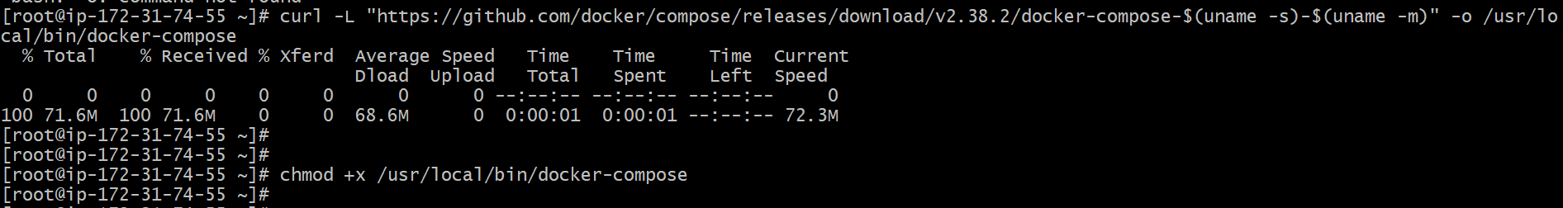

1. Create docker-compose.yaml file.

It define all the infrastructure requirements for their application within a single file.

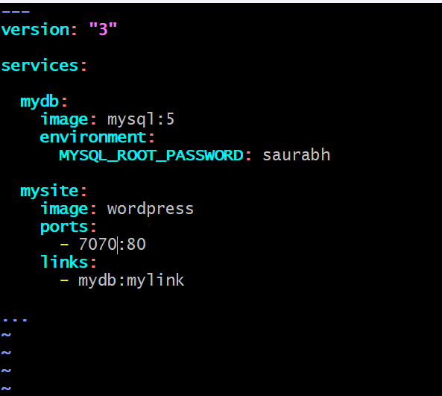

1. Start the docker-compose service

Docker-compose up -d

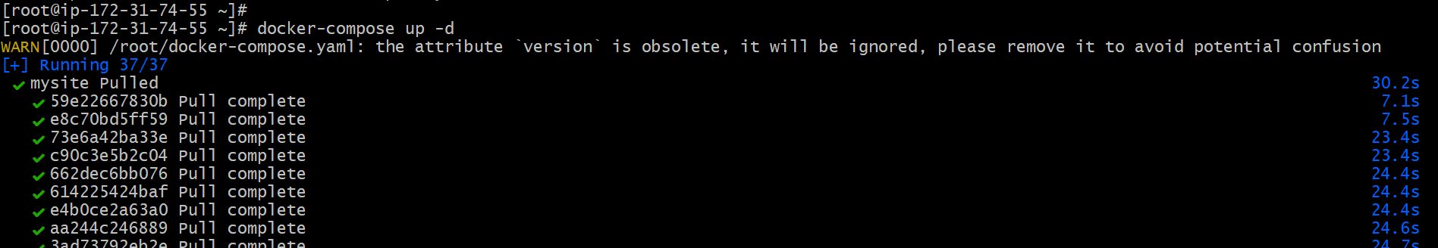

1. Finally we can see the wordpress website running.

1. Stop the running containers.



1. Delete the multiple containers

Docker rm $(docker ps -aq)

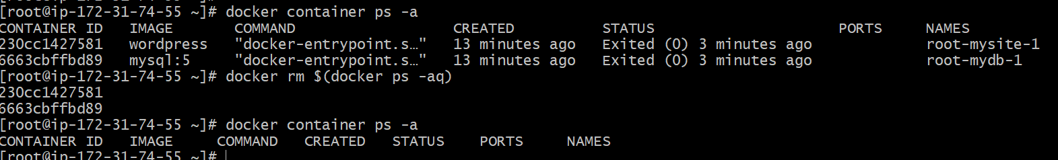

1. Delete the multiple images.

Docker rmi $(docker images -q)

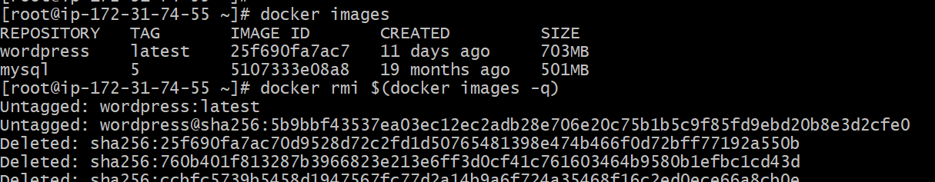

1. Similarly we can create another yaml file with docker images as wordpress , mysql and phpMyAdmin.

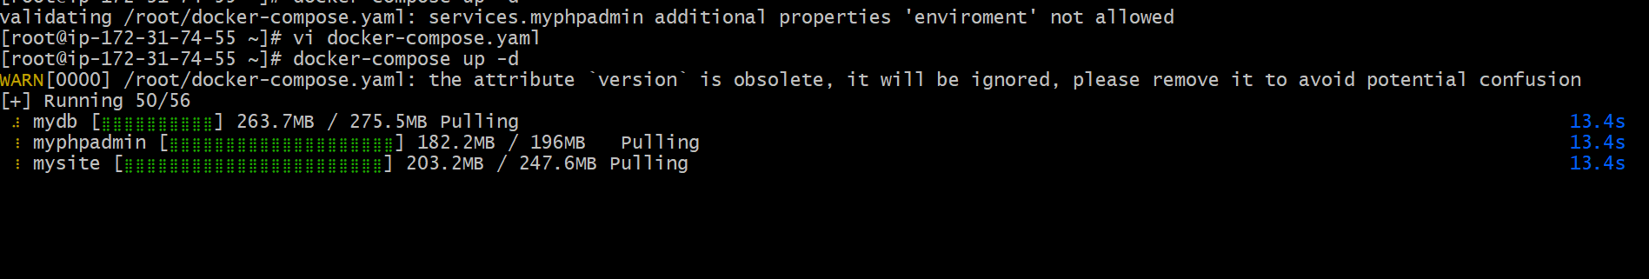

1. Successfully accessed phpMyAdmin.

